23CSE111 OBJECT ORIENTED PROGRAMMING
S2 B.Tech CSE
Department of Computer Science and Engineering
Amrita School of Computing, Amritapuri Campus
CASE STUDY
PHASE – 2 (Design)
Architectural Modelling (CO2)

Group No :C8
Team Members :
Roll No | Student Name
AM.SC.U4CSE25247 | SARVESH SUDHEER
AM.SC.U4CSE25235 | N SAMIKSHA
AM.SC.U4CSE25205 | ARJUN S P
AM.SC.U4CSE25217 | GAYATHRI RAJEEV

- Problem Title : Goods Vehicle Management and Booking System

STRUCTURAL DESIGN
- Class diagram (draw class diagram that shows different classes and their relationships. Use UML notations)
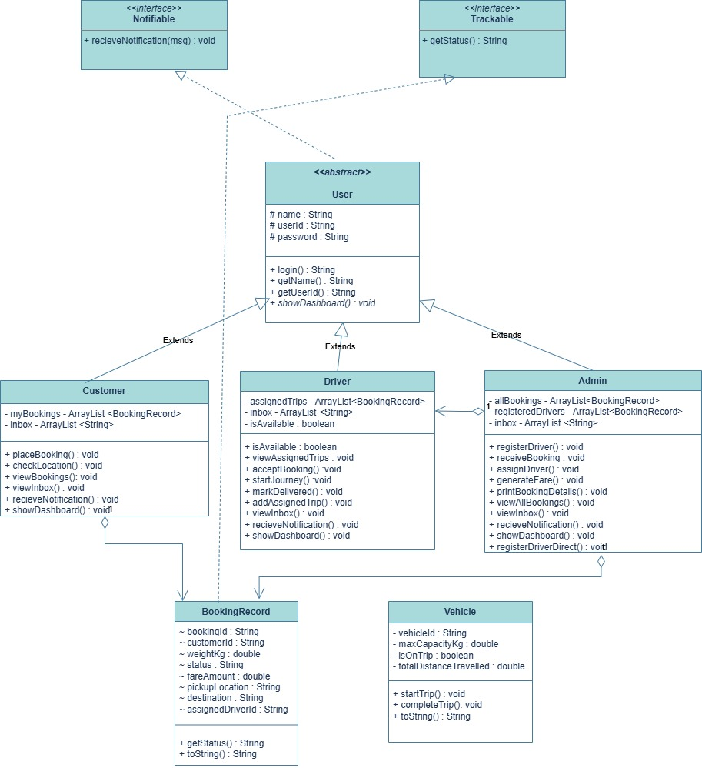

BEHAVIUORAL DESIGN
- Use-case diagram
- List of actors
- ADMIN
- CUSTOMER
- DRIVER
- List of use-cases
- ADMIN : Register Driver, Assign Trips, Manage Trips, Generate Fare, Print Details.
- CUSTOMER: Set Pickup/Destination, Track Trip, set weight, etc.
- DRIVER: View Available Trips, Book/Accept Assigned Trip, Update Trip Status.

- Use case diagram (use UML notations)

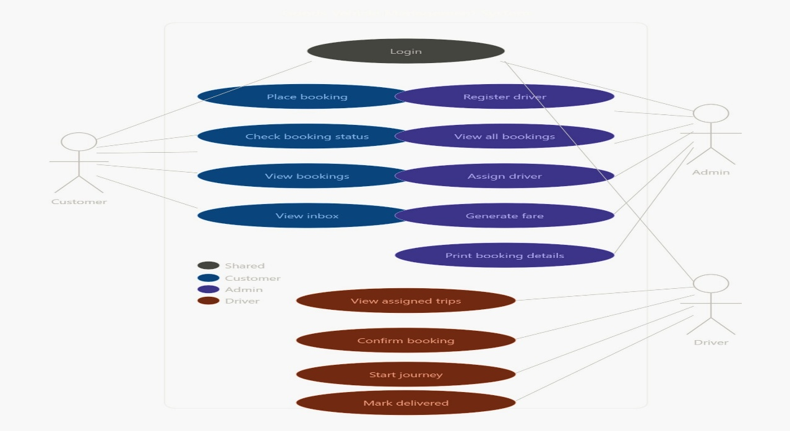
- Sequence diagram (use UML notations)
  - Choose key use cases and draw their sequence diagram. First describe the scenario in few sentences. Then draw the sequence diagram.
The sequence diagram lays out the whole process of booking and delivering goods. Three actors:
Admin
Customer
Driver

The Admin registers a driver, while the Customer enters what they need, where to pick up and drop off, the kind of vehicle, how heavy the load is. The Admin takes this info and figures out the fare.
The Admin picks a driver for the job. The Driver reviews the request and confirms it, During this part. Finally, when the delivery’s done, the Vehicle’s total distance travelled gets updated and Driver marks the job as “Delivered,” Admin prints out the whole receipt.
  - Choose key use cases and draw their sequence diagram. First describe the scenario in few sentences. Then draw the sequence diagram.

